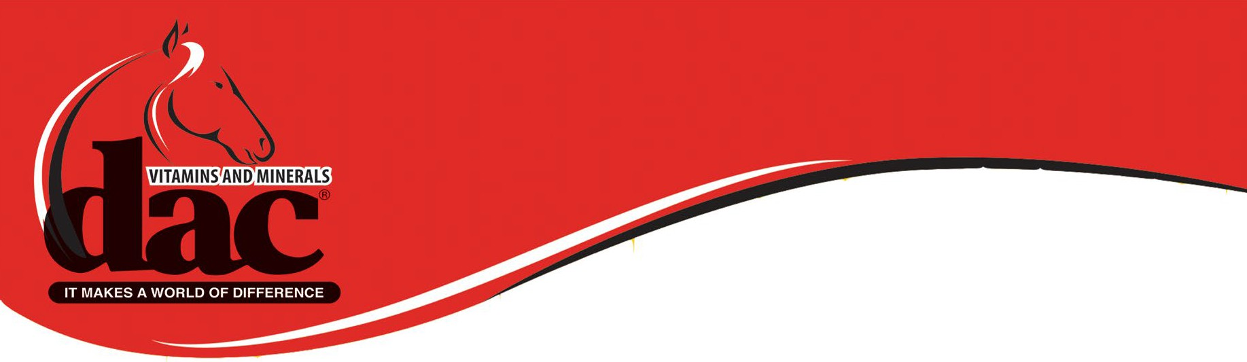

dac® Vitamins and Minerals Commitment to Excellence $1,000 Scholarship
2022-2023 Scholarship Application Available to High School Seniors
*Applications must be submitted by January 1, 2023*

Please email completed application to: aubrey@feeddac.com

As dac® Vitamins and Minerals approaches 40 successful years in business, we want to celebrate those of you who are beginning to pave your path to success! The dac® Vitamins and Minerals Commitment to Excellence $1,000 Scholarship will be awarded to an individual whose growth has been greatly impacted by equine involvement and plans to further their education or involvement within the equine industry.

Name of Applicant:
Email:
Phone:
Address:
Parent(s):
Social Media Handles (Instagram, Twitter, Facebook, TikTok, etc.):
High School:
Intended College:
Intended Major:
Equine Involvement:
Community Service:
Clubs, Organizations, Committees:
Major Awards (Equine & Academic):

500 Word Essay: How has your equine involvement prepared you for the future— what major skills have you acquired and how will you apply those moving forward?

Please include the following with the completed application & essay:
1 Recommendation (Please provide their Name & Phone Number)
Copy of Transcripts (3.0+ Cumulative GPA)

Signature of Applicant:

Thank you for your submission

For further details and disclaimers, please visit our website www.feeddac.com

